1. Find the Jacobian determinants for the transformation from Cartesian coordinates to polar coordinatesx=rcosθ, y=rsinθ

and from Cartesian coordinates to spherical coordinatesx=ρsinφcosθ, y=ρsinφsinθ, z=ρcosφ

syms x y r theta phi rho

x = r * cos(theta);

y = r * sin(theta);

jacobian1 = [diff(x, r) diff(x, theta)

diff(y, r) diff(y, theta)];

J1 = simplify(det(jacobian1))



clear x y

x = rho * sin(phi) * cos(theta);

y = rho * sin(phi) * sin(theta);

z = rho * cos(phi);

jacobian2 = [diff(x, rho) diff(x, theta) diff(x, phi)

diff(y, rho) diff(y, theta) diff(y, phi)

diff(z, rho) diff(z, theta) diff(z, phi)];

J2 = simplify(det(jacobian2))



2. Calculate the integral below and show the Jacobian matrix used.I=∫+∞−∞∫+∞−∞e−x2−y2dxdy

syms x y r theta

x = r * cos(theta);

y = r * sin(theta);

jacobian = [diff(x, r) diff(x, theta)

diff(y, r) diff(y, theta)];

J = simplify(det(jacobian));

eqxy = exp(-x^2-y^2);

eqrtheta = eqxy * J;

int(int(eqrtheta, r, 0, inf), theta, 0, 2*pi)



3. Nodal coordinates of a 1D element are:x1= 2.0,x2= 10.0andx3= 9.0. Plot the JacobianJon the natural coordinatesspace and explain the behavior between nodes 2 and 3.

n = 101;

xi = linspace (-1, 1, n);

C = [2; 10; 9];

for i = 1:n

J(i, 1) = C'* lin_deriv (xi(i));

end

plot(xi, J)

ylabel ("J")

xlabel ('xi')

grid

function dn = lin_deriv (xi)

dn = [xi - 1/2

xi + 1/2

-2*xi];

end

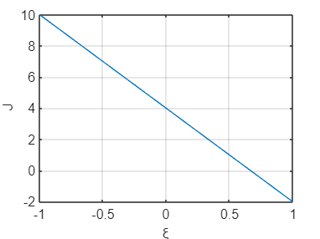

4. If the area of a triangular element is equal toA, show that the Jacobian determinant is equal to2A. Assume nodal coordinates(x1,y1),(x2,y2)and(x3,y3).

...

5. Write a routine that given the coordinates of a quadrilateral element with four nodes calculates the Jacobian at givencoordinates(ξ,η).

C = input('Coordenadas (x y):')

xi = input ('xi:')

eta = input ('eta:')

jacobian = C' * quad4_derivs (xi, eta);

J = det(jacobian);

function dn = quad4_derivs(xi, eta)

dn = [0.25*(-1.0+eta) 0.25*(-1.0+xi)

0.25*(+1.0-eta) 0.25*(-1.0-xi)

0.25*(+1.0+eta) 0.25*(+1.0+xi)

0.25*(-1.0-eta) 0.25*(+1.0-xi)];

end